Quiz 1

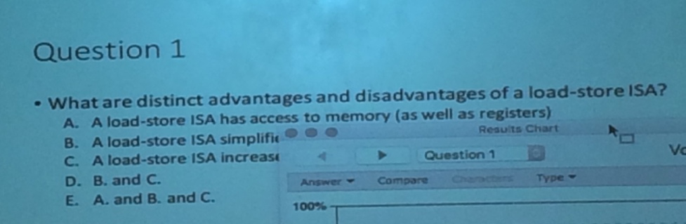

1. Answer: D

* All ISAs have access go to memory; nothing distinct about has access to memory (not distinct advantage)

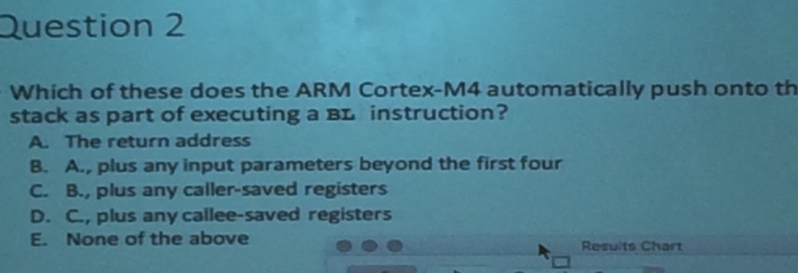

2. Answer: E

* B-D are done by caller/callee not by the BL instruction. Nothing gets pushed into stack by default

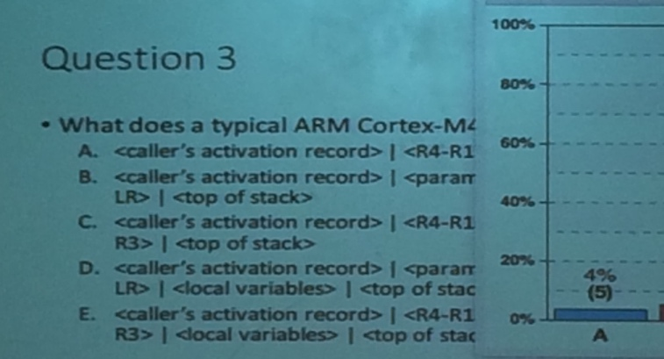

3. Answer: D

* Activation record look like. Callee needs to save all registers is uses and save LR if subroutine called
* R4-R11, LR are callee saved registers; boundary b/w branch and link is at <paramters beyond R0-R3> and <R4-R11 and LR>
* ARM is a callee saved record